

In the ESHS Robotics Club, also known as the “P.O.T.A.T.O.E.S.”, members build robots designed to accomplish a specific task. Participate in the FRC Competition, VRC Competition, the Drone Club and many other clubs, which are a part of the Robotics club! Every year, the club is hosted by talented and dedicated mentors, coaches and officers. Join the prestigious club and enjoy many benefits listed below!

* 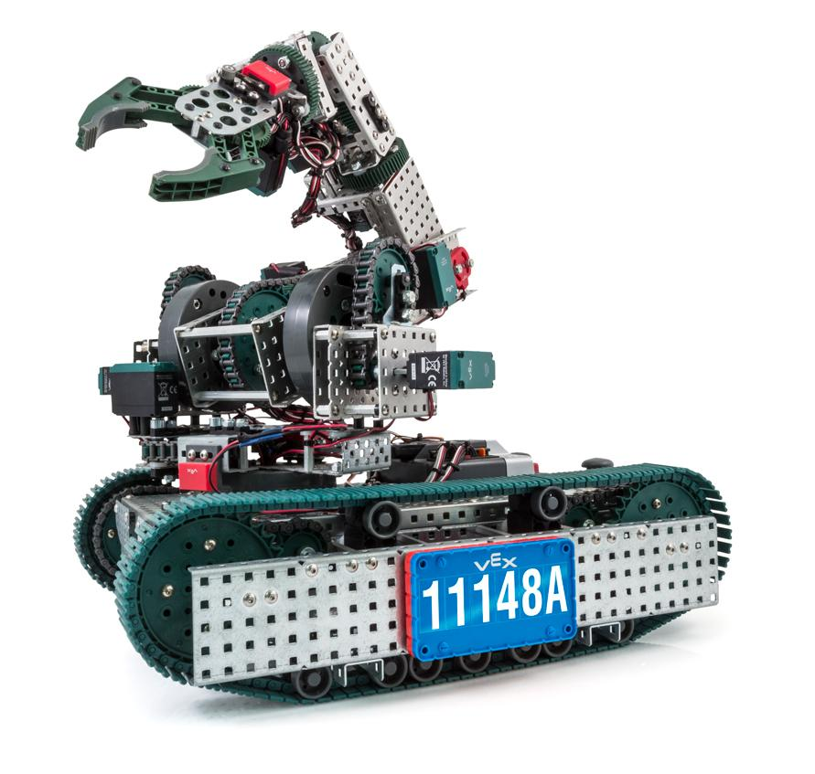Gain knowledge related to programming, 3D modeling, and building robots
* Develop skills vital to any S.T.E.M. field
* Expand scholarship and internship opportunities
* Amass knowledge from dedicated and experienced mentors
* Show your dedication and knowledge to college administrators via college applications
* Robotics Club is NOT just for S.T.E.M. majors!
* Meet every WEDNESDAY, 3:00 @ Engineering Lab

Join the Legendary P.O.T.A.T.O.E.S.

Question? ekofler_19@esusdstudents.org 24/7!!

Show Up WEDNESDAYS 3:00 @ Eng. Lab

Join the Legendary P.O.T.A.T.O.E.S.

Question? ekofler_19@esusdstudents.org 24/7!!

Show Up WEDNESDAYS 3:00 @ Eng. Lab

Join the Legendary P.O.T.A.T.O.E.S.

Question? ekofler_19@esusdstudents.org 24/7!!

Show Up WEDNESDAYS 3:00 @ Eng. Lab

Join the Legendary P.O.T.A.T.O.E.S.

Question? ekofler_19@esusdstudents.org 24/7!!

Show Up WEDNESDAYS 3:00 @ Eng. Lab

Join the Legendary P.O.T.A.T.O.E.S.

Question? ekofler_19@esusdstudents.org 24/7!!

Show Up WEDNESDAYS 3:00 @ Eng. Lab

Join the Legendary P.O.T.A.T.O.E.S.

Question? ekofler_19@esusdstudents.org 24/7!!

Show Up WEDNESDAYS 3:00 @ Eng. Lab

Join the Legendary P.O.T.A.T.O.E.S.

Question? ekofler_19@esusdstudents.org 24/7!!

Show Up WEDNESDAYS 3:00 @ Eng. Lab